FACULTY EVALUATION
Programme Name: SBVP ALUMNI MASTERCLASS - SCALE Module I Online Zambia (20th April 2026 - 24th April 2026)
Session: Business Plan reviews
Faculty Name: Benard Chege
No. of Respondents: 6
No. of Participants: 10
Evaluation Parameter | (%) Individual Score | (%) Programme Average
Punctuality (Commencement and Completion of Sessions) | 97 | 75
How well do you understand the core concepts presented? | 93 | 72
Rate your confidence in applying the new skills learnt | 87 | 72
Degree of Faculty preparedness for the sessions | 100 | 76
Content and methodology of the program | 97 | 77
Quality of class and group discussions | 90 | 72
The information presented in the course is relevant to my work (ministry) | 93 | 76
Average scores | 94 | 74

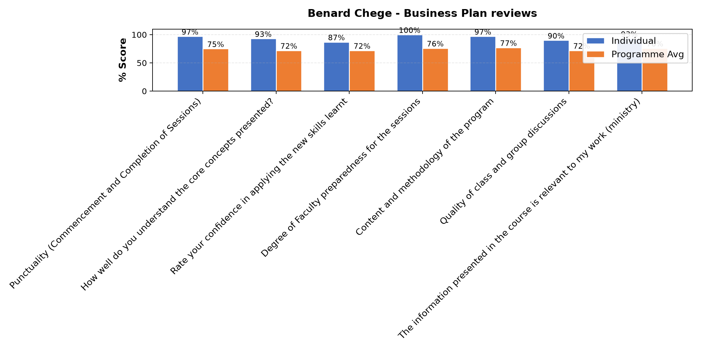

Comments & Feedback
- • The conclusion was abrupt
- • The lecturer had internet challenge and hence we could not reach the planned end time
- • Slow pace of implementation by contractors to build the hostels
- • Is just getting started turning the ideas into a written plan takes time we dont always have. All the same,the session gave me the tools,so I hope to apply them step by step with support from the team.
SUBMITTED THROUGH:
SBS Evaluation Automation System

